

PROFESSIONAL PRACTICES REPORT

Tuesday (3:00-5:00)

**Group Members:**

Davina David (34079)

Kainat Rizwan (33099)

Mhd Tazeem Hussain (34202)

Nadia Kanwal (33995)

Syed Asadullah Hussaini (34884)

Warda Aamir (33363)

**Submitted To:**

Dr. Salima Ahsan

**TABLE OF CONTENT**

1. Introduction………………………………………………………….. (3-5) 1.1 Image Management……………………………………..………… (3) 1.2 Impression………….……………………………………..….......... (4) 1.3 Self-Grooming…..….……………………………………..….......... (3) 1.4 Need of managing our image………..…………………..………… (5)
2. Cause of failure in impressing others………………………………… (5)
3. 6 ways to overcome fear of rejection…………………….……….. (6-12) 3.1Confidence………………………………………………..………… (6) 3.2 Appearance………….……………………………………..….......... (7) 3.3 Speaking Skills…..….……………………………………..….......... (8) 3.4 Listening Skills……………....………..…………………..……….. (9) 3.5 Being Optimistic……………………...…………………..………. (11) 3.6 Being Genuine……….………………...…………………..………. (12)
4. Personality and Self-Grooming……...…………………….………. (12-13)
5. Parts of Self-Grooming……………………………………..………… (14) 4.1 Self-Motivation……….…………………….………………............ (15) 4.1.1 Set Your Internal Standard ……………….…………..……….. (15) 4.1.2 See Problems as Opportunity………...…………....…..………... (15) 4.1.3 Take Blame and Credit…………...………………..…..……….. (15)

**4.2 Ethical Grooming………………………….……………..…….. (16-17)** **4.2.1 Respecting Others Opinion…...…...…………..………………... (16) 4.2.2 Be Unbiased…………………………..……………..…..……...… (16) 4.2.3 Take Blame and Credit…………..………….……..…..………... (17)**

**5. Tips and Tricks ………...……………………………………..……... (18-19)**  **5.1 On Daily Basics ...…………......……………………………..………..... (18) 5.2 at Professional Level……………………..……………..…..…...…….... (19)**

**6. Conclusion………………………………………………………..…….… (20)**

**IMAGE MANAGEMENT**

**IMPRESSION & SELF-GROOMING**

**What is Image Management?**

**Image =** general representation

**Management =** controlling things or people

So, Image Management means Self-presentation, self-promotion, and professional presence of your personality.



**Look at these stages and find where do you stand?**

If you do not manage your image then you will remain be at the stage you are.

To manage your image you should work on 2 things:

1. Impression: What you image you built
2. Self-grooming: How to maintain that image
3. **IMPRESSION:**

It is the overall effect of something e.g. on a person.

By impression we mean how someone build your image on their mind. It is much based on **1st Impression**.

ACTIVITY: a short video survey of how do people impress others?

Remember: your 1st Impression is the last one. So create it the positive one

Look at these picture and tell what impression does this image plots on your mind?



The Man is very much well-dressed but still he is creating a NEGATIVE image because he is chewing and blowing the gum which is giving his bad impression on others.



This Image is also giving a NEGATIVE impression because the girl is very much keen to talk but the guy is busy with his phone and ignoring the girl

So in the same way your image reflects Negative or Positive impression on others.

Why We Need To Manage Our Image?

* Image management matters because people make **assumptions** and **judgements** based on very limited information.
* You have just few seconds to make good first impression and it’s almost impossible to change it once it’s happened.
* In this short time, the other person forms an opinion about you based on your appearance, your body language, and your mannerisms
* So it’s worth giving each new encounter your best shot.

On that basis people opinions might like us or not



We all want to impress others but still we fail to do.

Why We Fail To Impress Others?

* We fail to impress others because we have a ***fear of rejection* (shyness)** i.e. we think people will laugh at us or criticize us.
* At the age of Confidence under construction, everyone had faced different past, different rejections.
* This fear make us lose our confidences even when we grew up i.e. as we grew this fear grew with us
* But we didn’t realized that we were insensible at that age and we never knew the difference between right and wrong.

Recognize at what point people rejects you?

**6 Ways to Overcome Failure of Rejection:**

By working on following things:

1. Confidence
2. Appearance
3. Speaking Skills
4. Listening Skills
5. Being Genuine
6. Being Optimistic

If you follow these steps victory is all your way.

1. **CONFIDENT:**

Being confident is the most important thing to impress others. We can win any fight by being confident on right path and by being calm.

**How to overcome fear of being confident?**

* 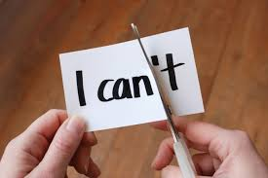By engaging with people and in different activities.
* Try new things.
* Talk more not less, through this we can interact more with people.
* Practice displaying confident body language. People judge us by our body language, posture and gestures.
* Be mindful, if we plan and get in different things by contributing and displaying our interest.
* Stop being shy. Shyness leads us to negative impact on others.

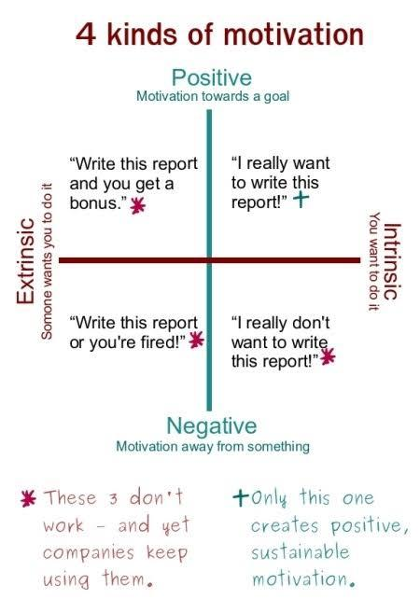**Confidence Building through Motivation:**

1. **APPEARANCE:**

Appearance is the second most important factor for impressing others.

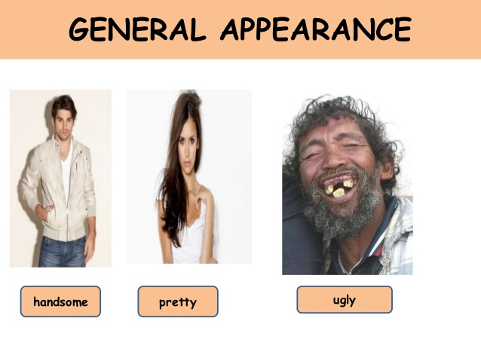

**How to overcome fear of poor appearance?**

* Give a decent look.
* By wearing comfortable clothes.
* Know the occasion.
* Work on your body language.
* Feel confident.

**“We should not judge someone by their appearance.”**

If you give a decent look, wear comfortable clothes you will feel confident.

**Formal Way To Appear In Interview**

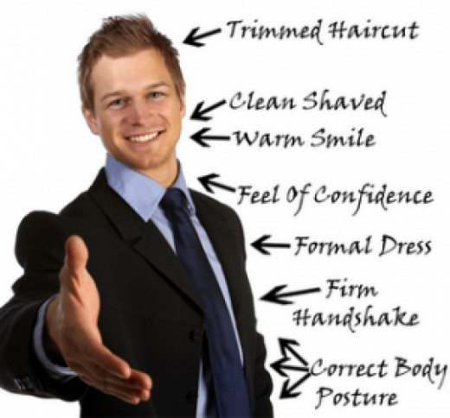

1. **SPEAKING SKILLS:**

Speaking shows how expressive you are.

How to overcome fear of **Speaking**?

* **Know your material:**

Pick a topic you are interested it. Know more about it than you include in your speech. Use conversational language

* **Know audience interest:**

Understand your audience and their taste and arrive at interesting topic.eg. if you speak different languages so audience can not understand or never show interest.

* **Think before speaking:**

you must think at least one time before speaking.

* **Observe yourself in mirror**:

It’s a good practice, you can check your body language that how you can communicate with other peoples.

* **Practice, Practice, Practice:**

Rehearse out loud with all equipment you plan on using.

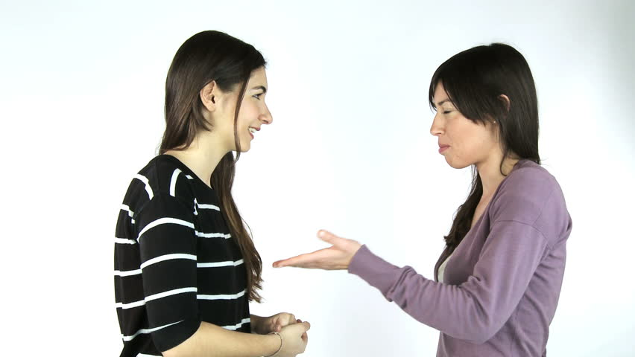

Be expressive while speaking (Use hands) because it shows how keen you are while talking with your listener.

**Remember:** Your speaking reflects your thoughts. Use Positive words while expressing yourself

1. **LISTENING SKILLS**

The listening process includes following processes:

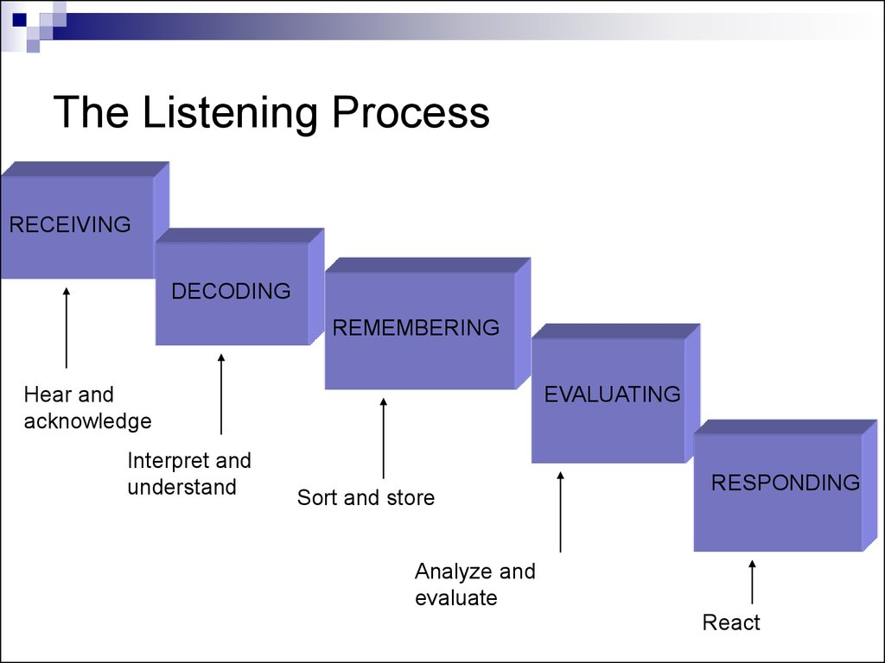

1. **Receiving**:

It is the intentional focus on hearing a speaker’s message, which happens when we filter out other sources so that we can isolate the message and avoid the confusing mixture of incoming stimuli. At this stage, we are still only hearing the message.

1. **Understanding:**

This is the point in the listening process where you’re able to plan your response. Understanding takes place after you’ve received the information from the speaker, and begin to process its meaning.

1. **Remembering:**

What good would it do in a conversation if you forgot everything the speaker had just said? This stage of the listening process might seem very similar to the first two, but it goes beyond merely absorbing and processing information

1. **Evaluating:**

It’s at this stage where you can begin to prepare for your response, but remember: you’re still a listener, not a speaker. After the message has been absorbed, processed, and remembered, you can begin to sort the information into pieces.

1. **Responding**:

If you’ve completed the receiving, understanding, remembering, and evaluating portions of the listening process, responding should be easier than ever. You’ll be prepared to address the speaker’s most important points, with an awareness of the circumstances and context surrounding their words.

**How to overcome fear of Listening?**

* Follow listening steps in sequence not parallel.
* Show interest to your speaker
* Give your opinion after speaking
* Work on your body language because that speaks when you are silent
* Don’t make fun just listen carefully

ACTIVITY:

Audio Remembering Test (hear the audio twice then few clues will be given at the end and check how much did you remembered and see how much good listener you are?)

1. **TO BE OPTIMISTIC**

Optimistic means Positive Approach

**How to overcome this fear?**

* Try to smile more often.
* If you can, avoid the company of negative.
* Take more care of your appearance and how you dress. When you look good you will feel more confident and positive.
* If you think positive, you live positive and you will always be happy.

If you are think positive you will always end up with happiness and look different from others



1. **BEING GENUINE**

In this busy world, there is a lot of fakery, deception and contrived perfection. It is possible to be true to yourself and people around you.

**How to overcome fear on being genuine?**

* Be real and never feel shy. Let people criticize you let them say whatever they want just be on right path and don’t get your true side hide.
* Stop being attention seeker.
* If we know that we are right than let people know this.
* Do not do things or take decisions according to others will or perceptions.

**2. SELF-GROOMING:**

Before knowing about Self-grooming we need to know

**What is personality?**

The relatively enduring traits that makes an individual and unique

**Determinant of Personality**

Some of our personality may be attributed to biology and genetics. However people can make changes to their personality if they were determined

**Dimension of Personality**

As in class activity we have analyzed our dimensions of personality

that were:

1.ExtraVersion

2.Agreebleness

3.Conscientiousness

4.Neuroticism

5.Openness

**What is grooming?**

It is the process of making yourself neat and attractive.

The thing which you which you do to make yourself and your appearance tidy and pleasant.

**What is personal grooming?**

Personality grooming mean improve one outer and inner self to bring about a positive change to life. Each individual distinct person that can be develop polished and refined.

**Activity:**

A Cell-phone is displayed without battery and sim. So does that cell-phone worth it?

Surely not because it is useful now. In the same way we are like this cell-phone without battery and sim when we do not groom our personality

**Reasons for Personal Grooming**

* Boosting one confident
* Improving communication
* Language speaking ability
* Develop certain hobby and skill
* Learning fine etiquette and skill
* Adding style and grace do the way one look

As beautifully quoted,

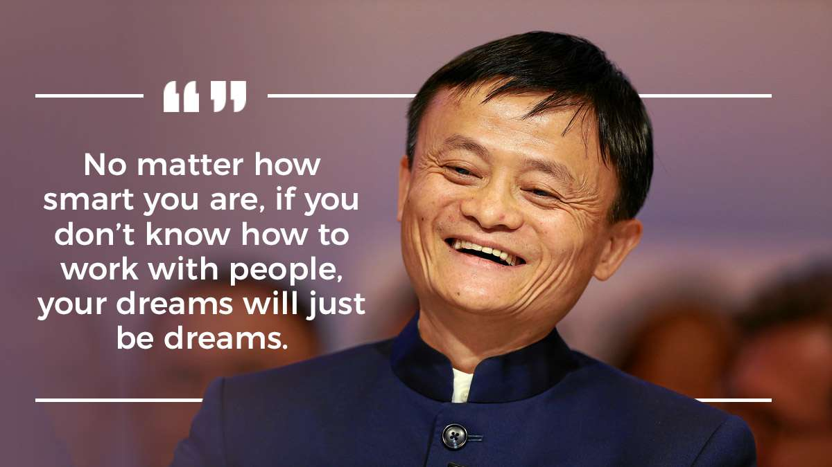

It means to achieve your goals who must know how to work with people.

**We have split Self-Grooming in 2 parts:**

1. *Self-Motivation Grooming:*
2. Set Your Internal Standard
3. See Problems As Opportunity
4. Take Blame And Credit
5. *Ethical Grooming:*
6. Respecting Others Opinion
7. Be Unbiased
8. Be Thankful For What You Have

**SELF-MOTIVATION GROOMING:**

1. **Set Your Internal Standard:**

Identify your strengths and weakness and never feel yourself de-motivated:

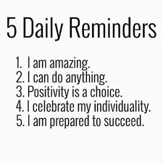

1. **See Problems As Opportunity:**

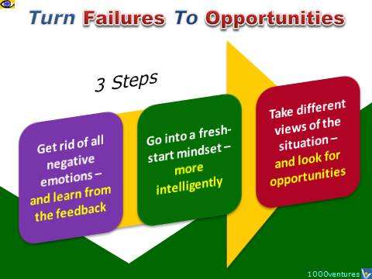**Step1:**

Do not learn the criticism just learn from your criticism

**Step2:**

Forget your criticism and belief that you can do it again in much better way

**Step3:**

Take another chance and avail it

Remember: Ignore Reactions, Focus on Improvements

1. **Take Blame and Credit:**

Accept your flaws and take credit of your grooming

**ETHICAL GROOMING:**

1. **Respecting others opinions:**

* As we know in this world we all have different thinking different mindset due to our experiences in life.
* If we respect others opinions we get to know that no one is perfect in this world and we get better knowledge about human behaviors and its make our life easier.
* Respecting others opinions does not mean being untrue to your own.

**So what is your opinion about this picture?**

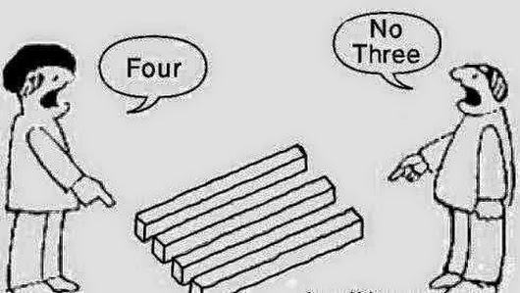

Actually from the left end its 4 and from the right end its 3

1. **Be Unbiased:**

Being biased means showing partiality to one.

**How can you act Un-biased?**

Follow these steps to keep yourself unbiased:

* Choose Your Words Wisely
* Avoid Sweeping Generalizations
* Avoid Emotional Pleas (a request made in an urgent and emotional manner)

If we create an assumptions for someone with knowing him/her this is a biased way. First and foremost, practice never making assumptions.

**What is better Apple or Android?**

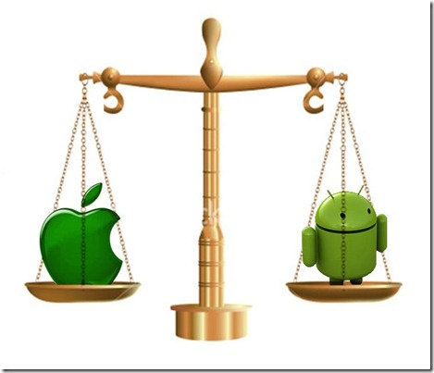

Actually, your opinions depends upon your experience with it but it doesn’t means everyone will have same experience. So stop being **biased**.

1. **Be thankful for what you have:**

* Be thankful for what you have, you'll end up having more.
* If we think that we don’t have this we want this we end up with full of negativity so try to be thankful for what you have there are many people in this world who have nothing.

**Remember:**

*“So be kind be thoughtful be genuine but most of all be thankful.”*

**Activity:**

Find the flaws in the video (Few mistakes we make in our life [acted by group members] while impressing and self-grooming and tell what we should have done)

**TIPS & TRICKS**

**1. DAILY BASIS:**

Follow these tips daily to let people like you instantly.

* **Give flooding smile:**

Show that you are glad to meet the person

* **Keep sticky eyes:**

Keep good eye-contact. Recognize the color of the speaker

* **Limit fidgets:**

Fidgets are the small movements one makes in nervousness. Limit that because it shows you are weak and afraid of that person.

Move hands while speaking and fold hands while listening

* **Big Baby Pivot:**

Pivot means undivided attention. As you give undivided attention to the baby unintentionally in the same way do it with your speaker.

* **Use positive words:**

Avoid using hopeless words like I can’t, I am shy etc. because your listener might oppress you.

* **Be Confident but not over-confident:**

Know the difference between confident and over-confident because people like you when you are confident but not when you are over-confident.

1. **PROFESSIONAL LEVEL**

* **Be punctual:**

Being punctual shows that how much importance you have of time.

* **Keep your work up to date:**

Never leave your work for tomorrow



* **Keep Full knowledge of your work:**

You should know each and every thing of your task

* **Words and action should be similar:**

Your commitments should match your actions

* **Work differently:**

Everyone does work but the one who works differently impresses more

* **Share attributes of success to others:**

Never think that if I will share my success attribute people will come in my competition

* **Give true appreciation to others:**

Appreciate others only when they deserve. Never give false appreciation instead teach what wrong you have done.

**CONCLUSION**

* Image Management is Self-presentation of our personality.
* It includes Self-Impression & Self-Grooming.
* Self-Impression is built at 1st sight whereas self-grooming is maintaining the impression built.
* We need to impress others in order to develop self-power.
* We are not born with fear, it is just our mindset.
* Criticism is the name of opinions of different people at the same time.
* To avoid shyness, we must face challenges.
* We can overcome our failure of impressing others by working on our-selves such as our Confidence, body language, Communication skills and by being genuine
* Self-Grooming is much based on Self-Motivation & Social Ethics
* Few Tips at First Impression: Flooding smile, being social, maintaining eye-contact, using positive words, limit-fidget**.**
* **Remember:** know that not everyone will like you, and that’s okay.
* Time will turn criticism into success only if you work on it.

Now we all know the importance of self-grooming and impression but when are we going to implement?

**Motivational Message:**

We all want to impress others and we will do it from today, from the very moment because we all want to build a strong personality as we do not want to face any more criticism in our life. Once we groom ourselves then 1 day Surely, **Our criticism will turn into applause, the** **finger that points us will turn into thumb**.

Well Quoted,

**“*Don’t pretend to be what you are not, instead, pretend to be what you want to be, it is not pretence, it is a journey to self-realization.”***   
― **Michael Bassey Johnson**

**Explanation of Quotation:**

***Do not imitate someone to look good but to be good***

**REFERENCE:**

**Books:**

* **“Rich dad and poor dad” by Robert Kiyosaki. (Self-grooming, Tips)**
* **“The Secret” by Rhonda Byrne. (Conclusion)**

**YouTube:**

* [**https://www.youtube.com/watch?v=yCyA13YRlU0**](https://www.youtube.com/watch?v=yCyA13YRlU0)
* [**https://www.youtube.com/watch?v=TD884Dl-kLc**](https://www.youtube.com/watch?v=TD884Dl-kLc)

**Google:**

* [**https://www.google.com.pk/search?q=activities+to+gain+confidence&rlz=1C1CHBF_enPK757PK757&oq=activities+to+gain+confidence&aqs=chrome..69i57.21435j0j1&sourceid=chrome&ie=UTF-8**](https://www.google.com.pk/search?q=activities+to+gain+confidence&rlz=1C1CHBF_enPK757PK757&oq=activities+to+gain+confidence&aqs=chrome..69i57.21435j0j1&sourceid=chrome&ie=UTF-8)
* [**https://www.google.com.pk/search?q=activities+to+gain+confidence&rlz=1C1CHBF_enPK757PK757&source=lnms&tbm=isch&sa=X&ved=0ahUKEwjk0e7EyIjeAhVaXCsKHeqOCNMQ_AUIDigB&biw=1422&bih=685&dpr=0.9#imgrc=w9IYrZsGxhqHYM**](https://www.google.com.pk/search?q=activities+to+gain+confidence&rlz=1C1CHBF_enPK757PK757&source=lnms&tbm=isch&sa=X&ved=0ahUKEwjk0e7EyIjeAhVaXCsKHeqOCNMQ_AUIDigB&biw=1422&bih=685&dpr=0.9)
* **https://www.positivityblog.com/optimist/**
* [**https://www.google.com.pk/search?q=how+to+impress+others+by+being+genuine&rlz=1C1CHBF_enPK757PK757&source=lnms&tbm=isch&sa=X&ved=0ahUKEwj395Ke2YjeAhUIPI8KHbSBDg4Q_AUIDigB&biw=1422&bih=685#imgdii=qXtZTTvUw1UJtM:&imgrc=Bl1r_RWYB75-hM**](https://www.google.com.pk/search?q=how+to+impress+others+by+being+genuine&rlz=1C1CHBF_enPK757PK757&source=lnms&tbm=isch&sa=X&ved=0ahUKEwj395Ke2YjeAhUIPI8KHbSBDg4Q_AUIDigB&biw=1422&bih=685#imgdii=qXtZTTvUw1UJtM:&imgrc=Bl1r_RWYB75-hM)
* [**www.brainyquote.com/**](http://www.brainyquote.com/)
* **https://www.fastcompany.com/3036026/5-ways-to-improve-your-listening-skills**

**______________________THANKYOU­­­­­­­­­­­­­­­­­_____________________**